**Screenshots**

**Test Case 1**: Turn the light bulb on and set the color (if the light bulb is already on, the operation should make no change)

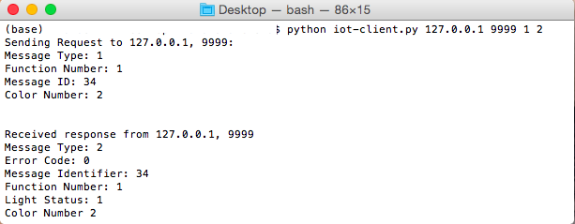

**Test Case 2**: Change the light color

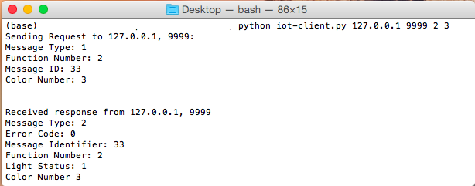

**Test Case 3:** Determine the status of the light: on+color, off, broken

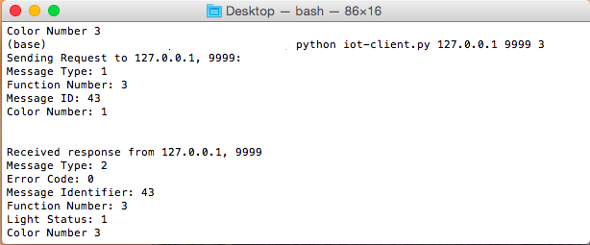

**Test Case 4:** Turn the light off (If the light bulb is already off, the operation should make no change)

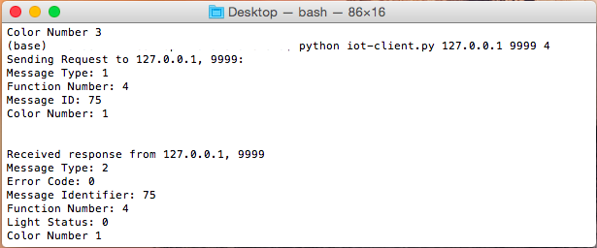

**Test Case 5**: Demonstrate operation when client sends a message with incorrect format to server

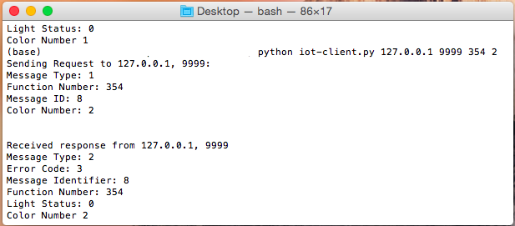

**Test Case 6**: Demonstrate operation when color not supported

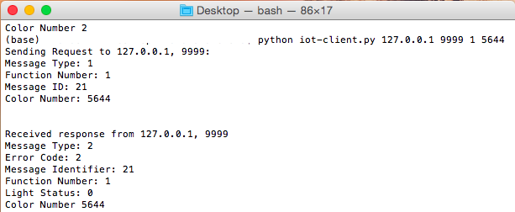

**Test Case 7**: Demonstrate client operation when server not running

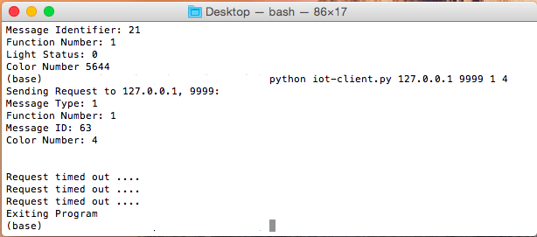

**Server**:

